CDR – Missing Summary Macro Icon Images
- Missing summary icon images. The “Patient” and “HP” icons display as people (or sometimes nothing at all) rather than “HP” and “PAT”. See images below. The macros still work.
IN FRANCK ON MY DESKTOP:
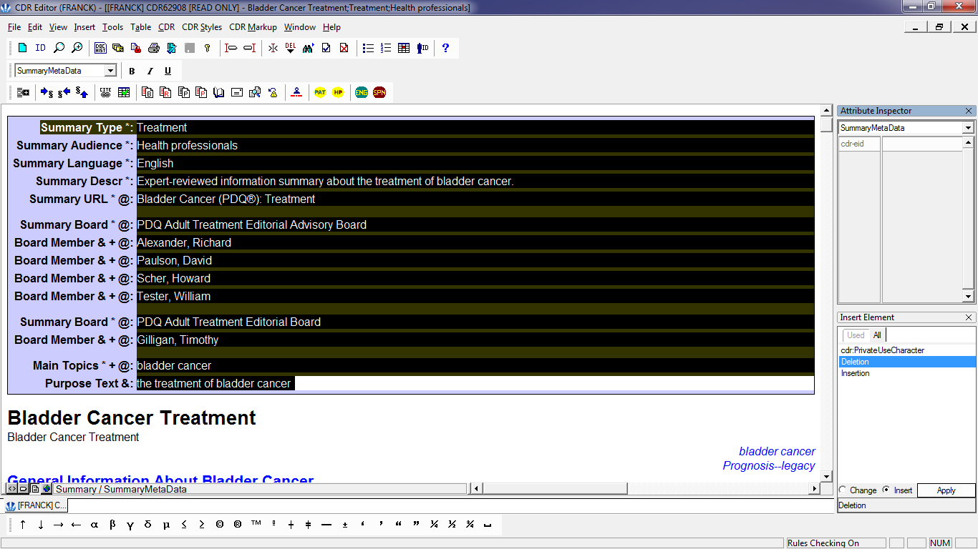
IN THE BASTION HOST:
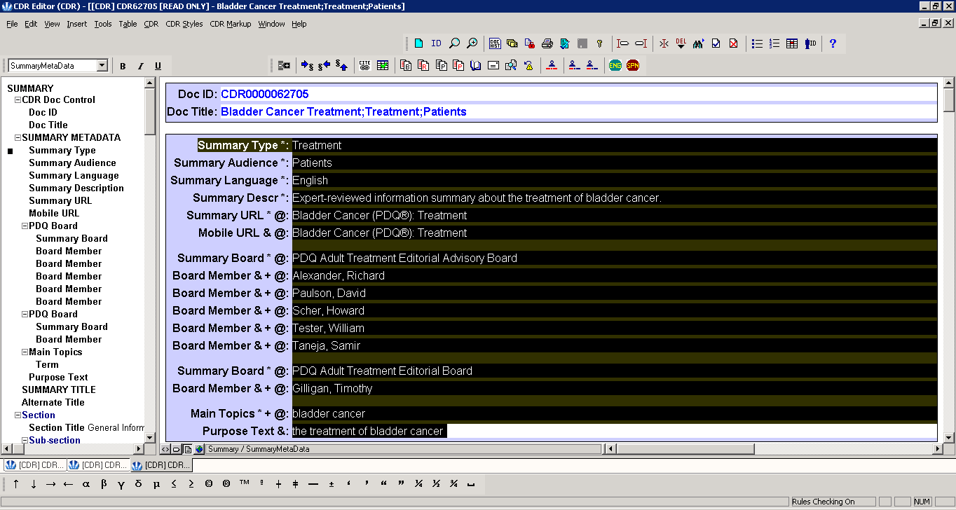
Here, the icons show up as people.
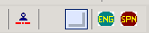Here, the icons are only visible when you hover over them.

